ARE YOU

- A Community Organisation domiciled in Central Hawke’s Bay Yes / No

- A voluntary non-profit organistion?
Yes / No

- An organisation who wholly or mainly serves the residents of Central Hawke’s Bay?
Yes / No

APPLICATIONS CLOSE FRIDAY 06 August 2021
If you need more information about the Community Voluntary Organisation Support Fund
(CVOS) or want help filling out this form please contact Council by phoning 857 8060,
or emailing funding@chbdc.govt.nz

COMMUNITY VOLUNTARY ORGANISATION SUPPORT FUNDING SCHEME CRITERIA

CATEGORY 2: $20,000 for ongoing support to existing community groups who provide
community services in Central Hawke’s Bay.

Criteria:
- Funding will be provided for costs that enable the continual running of a viable service that is deemed to be of considerable benefit to the community of Central Hawke’s Bay. The onus of proof regarding benefit lies with the applicant.
Costs may include:
- Rental of building
- Power charges
- Stationery
- Photocopying
- Postage
- Telephone/Fax
- Insurance
- Financial reporting costs
- Personnel costs essential to the provision of the service
- Marketing
Costs which are not eligible include the following:
- Rates payments
- Facility development, and other costs considered not being essential to the continual
running of the service
- Community groups must be domiciled in Central Hawke’s Bay and be a voluntary non-profit organization serving wholly or mainly the residents of Central Hawke’s Bay.
- The group should receive a wide measure of support from their community. Please supply letter/s of support from Individuals/Groups who will benefit from your project.
- The level of funding available from other agencies, including fundraising, will be taken into account when assessing the project.
- Grants made for Category 2 will not exceed 50% of total ongoing organizational costs. However, if an organization is able to provide evidence that it is experiencing extreme hardship and the continuation of the viable service is at risk, a grant higher than 50% may be awarded.
Applicants must provide as part of their application:
  - A copy of the most recent years set of financial accounts.
  - Statistics or factual information which demonstrates the level of activity
or achievements for the past year.
  - Evidence of the support the group received from the community.
All applicants must provide a report on the project by 31 March in the year following
the grant. Failure to do this could negate future funding requests from the organisation.

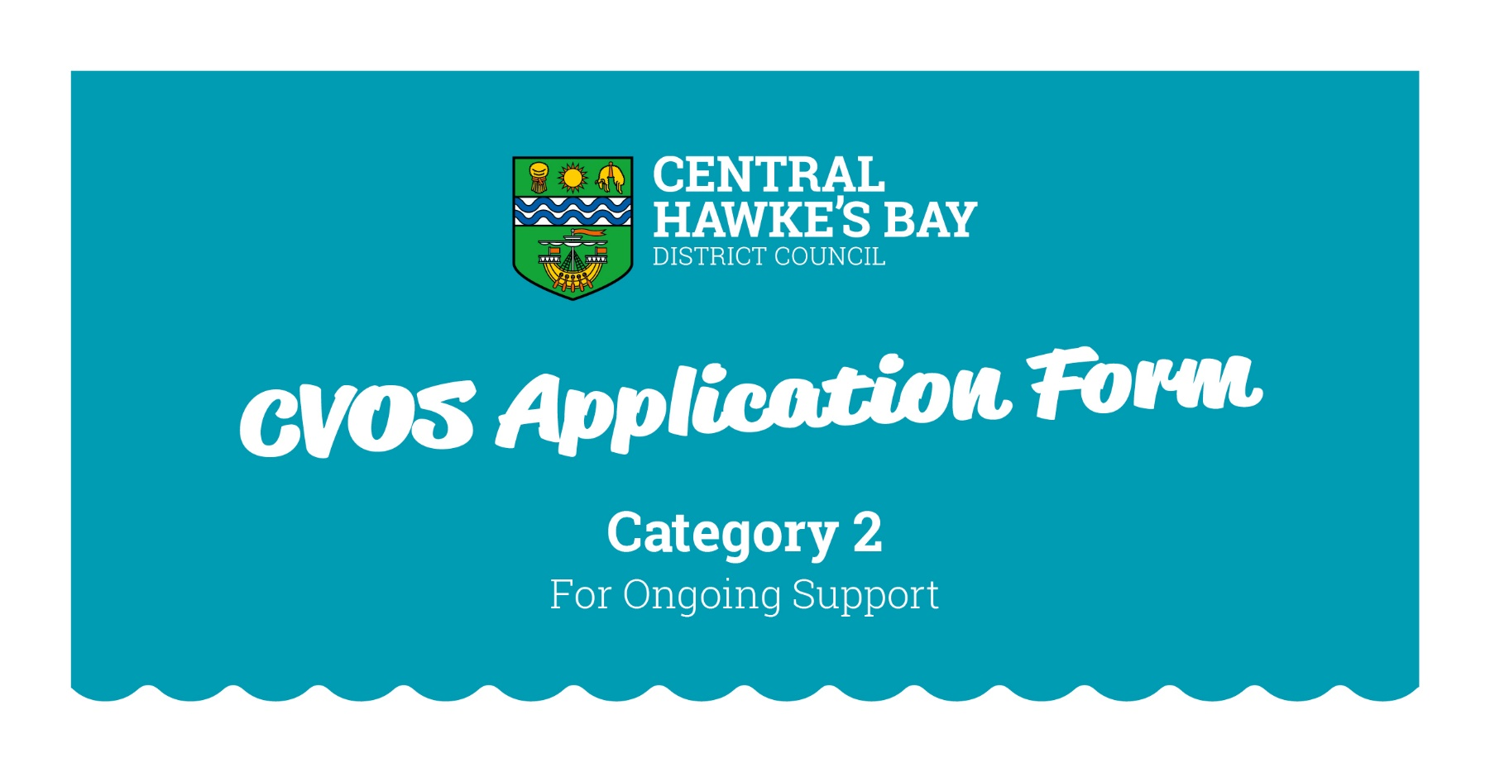

1. GENERAL DETAILS

Name of Organisation:
Postal Address:
Street Address:
Email:
Contact Phone Number/s:

Contact names of two persons within the Organisation:
Please give the names of two people who we can contact if we need more information.
The first contact must be the person who filled out the form. Under the Privacy Act (1993) you
must ask permission from these people before giving their details.

Name
Role
Contact Phone Number/s
Name
Role
Contact Phone Number/s

Are you a Voluntary Organisation? Yes / No

How many Volunteers does your Organisation have?____________________________________

How many Voluntary Hours on Average per week
will be worked within your Organisation? ______________________________________

How many paid employees does your organisation have? Full time_____ Part Time______

Number of paid hours per week ____________________

How many individuals within the Community will benefit from your community organistion this year?

Is your Organisation a legally constituted Society or Trust? Yes / No

2. FINANCIAL DETAILS

Are you registered for GST? Yes / No

If yes, write your GST number here:

If you are registered for GST please do not include GST in these costs.
Please round all figures to the nearest dollar.

Bank Account Name______________________________________________________________

Bank Account Number__ __/__ __ __ __/__ __ __ __ __ __ __/__ __ __

2.1 Your Organisation

Full details of activities of your community group, including details of the services provided
in the last 12 months:

2.2 Running Costs

Please list the running costs for your organisation.
1 |  | $
2 |  | $
3 |  | $
4 |  | $
5 |  | $
6 |  | $
7 |  | $
8 |  | $
9 |  | $
 | Total Running Costs: | $

2.3 Please indicate how you intend to cover the running costs for
your organisation:

How will your group contribute financially to your organisation?
Sponsorship: | $
User Fees: | $
Fundraising: | $
Loans: | $
$ Already spent on project: | $
$ Available and earmarked for this project: | $
Donated materials: | $
Other: | $
Your total contribution is: | $
Amount you are applying for: | $

2.4 Are you applying to any other Organisation for funding assistance for your running costs?

Yes / No
If yes, please list below:

Organisation | Requested | Amount Received

2.5 Have you received funds from any Organisation in the last two years to help fund your running costs?

Funding Organisation | $ Amount | Year
CVOS
NZ Lottery Grant Board/COGS
Community Trust Organisations
Any Government Department
Others:

2.6 Tell us why your organisation should be funded, and what public

service benefit it will be to the community.

(Use another page if you need more room)

4. Declaration:

I hereby declare that the information supplied on behalf of my organisation is correct and that I will forward a report on the success of the organisation to Central Hawke’s Bay District Council by 31 March 2022.

I consent to Central Hawke’s Bay District Council keeping and using the personal contact details provided above for the purpose of the Community Voluntary Organisation Support (CVOS) Funding Scheme. This consent is given in accordance with the Privacy Act 1993.
Name:
Signed:
Position:
Date:

Please include with your application copies of your latest financial statements and any other supporting documents that help to demonstrate the need for and/or the support of the community for your organisation. Please refer to the Checklist in the Criteria Section of this Application Form.

Please post or deliver this application to:

Community Voluntary Organisation Support Funding Scheme
Central Hawke’s Bay District Council
Ruataniwha Street, Waipawa
P O Box 127
WAIPAWA 4240

Applications close on:
Friday 6 August 2021 at 4.30pm
No late applications will be accepted.

