ARE YOU

- A Community Organisation domiciled in Central Hawke’s Bay? Yes £ / No £

- A voluntary non-profit organisation? Yes £ / No £

- An organisation who wholly or mainly serves the residents of Central Hawke’s Bay?

Yes £ / No £

If you ticked yes to all of the above, please see overleaf for further fund criteria and application form.

APPLICATIONS CLOSE FRIDAY 06 August 2021
If you need more information about the Community Voluntary Organisation Support Fund
(CVOS) or want help filling out this form please contact Council by phoning 857 8060,
or emailing funding@chbdc.govt.nz

COMMUNITY VOLUNTARY ORGANISATION SUPPORT FUNDING SCHEME CRITERIA

CATEGORY 1: $10,000 to groups seeking grants for New Community Initiatives/Projects.

Category 1 funding is for Community Groups who have not received funding from Community Initiatives before, or groups who have received funding but are applying for a new project.

Criteria:
- Community groups must be based in Central Hawke’s Bay and be a voluntary non-profit organisation serving wholly or mainly residents of Central Hawke’s Bay.
- The application must demonstrate that the project is in response to a significant need in
the community.
- The group should receive a wide measure of support from their community. Please supply letter/s of support from Individuals/Groups who will benefit from your project.
- The level of funding available from other agencies, including fundraising, will be taken
into account when assessing the project, as will the contribution being made
by the applicant.
- The project should wholly or mainly benefit residents of Central Hawke’s Bay.
- Projects that are eligible for or have received funding from other agencies may be
considered for funding from CVOS. However, priority will be given to projects which
are unable to source funding from elsewhere.
- Applicants that have received funding from CVOS previously for the same project
are not eligible for funding.
- Grants made for Category 1 projects will not exceed 75% of the total cost
of the individual project.
- Projects will be prioritised and the level of funding granted will be based on this.
- The Assessment Committee is allowed the flexibility to allocate excess funds from
Category 1 to Category 2 in those years when there are insufficient worthy applicants
to receive grants from Category 1.
- There must be evidence of the long term sustainability of the project.

Applicants must provide as part of their application:
  - A copy of the most recent years set of financial accounts.
  - Statistics or factual information which demonstrates the level of activity
or achievements for the past year.
  - Evidence of the support the group received from the community.

All applicants must provide a report on the project by 31 March in the year following
the grant. Failure to do this could negate future funding requests from the organisation.

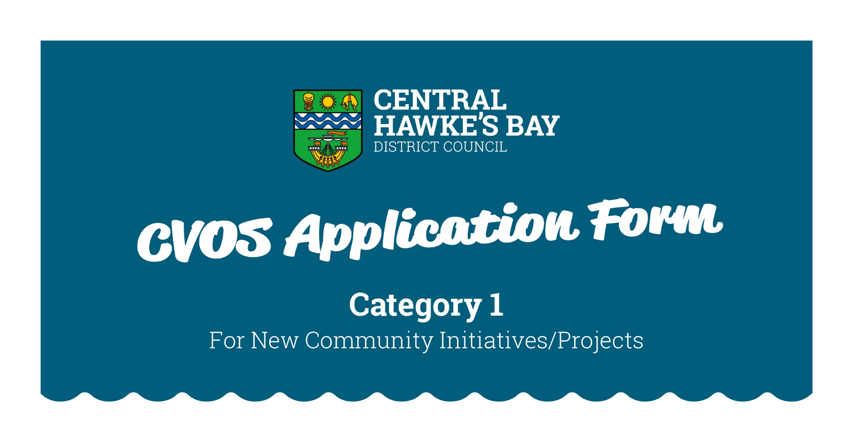

1. GENERAL DETAILS

Name of Organisation:
Postal Address:
Street Address:
Email:
Contact Phone Number:

Contact names of two persons within the Organisation:
Please give the names of two people who we can contact if we need more information.
The first contact must be the person who filled out the form. Under the Privacy Act (1993) you
must ask permission from these people before giving their details.

Name
Role
Contact Phone Number/s
Name
Role
Contact Phone Number/s

Are you a Voluntary Organisation? Yes £ / No £

How many Volunteers does your Organisation have?

How many Voluntary Hours on average per week will be worked within your Organisation?

How many paid employees does your organisation have? Full time_____ Part Time______

Number of paid hours per week ____________________

How many individuals within the Community will benefit from your new community initiative/project?

Is your Organisation a legally constituted Society or Trust? Yes £ / No £

2. FINANCIAL DETAILS

Are you registered for GST? Yes £ / No £

If yes, write your GST number here: ££ £££ £££

If you are registered for GST please do not include GST in these costs.
Please round all figures to the nearest dollar.

Bank Account Name______________________________________________________________

Bank Account Number__ __/__ __ __ __/__ __ __ __ __ __ __/__ __ __

2. 1 DETAILS OF THE COMMUNITY INITIATIVE/PROJECT

2.2 Project items

Please list the costs for this project.

1 |  | $
2 |  | $
3 |  | $
4 |  | $
5 |  | $
6 |  | $
7 |  | $
8 |  | $
 | Total Cost of Project | $

2.3 Please indicate how you intend to fund this Project:

How will your group contribute financially to this project?

Sponsorship: | $
User Fees: | $
Fundraising: | $
Loans: | $
$ Already spent on project: | $
$ Available and earmarked for this project: | $
Donated materials: | $
Other: | $
Your total contribution is: | $
Amount you are applying for: | $

2.4 Are you applying to any other Organisation for funding assistance for this project?

Yes £ / No £
If yes, please list below:

Organisation | Requested | Amount Received

2.5 Have you received funds from any Organisation in the last two years for this project?

Funding Organisation | $ Amount | Year
CVOS
NZ Lottery Grant Board/COGS
Community Trust Organisations
Any Government Department
Others:

2.6 Tell us why this project should be funded, what public service

benefit it will be to the community and provide details of the long term sustainability of the project
(Use another page if you need more room)

If this application is for a new project, you need to give us information to show
that there is a significant need in the community.

4. Declaration:

I hereby declare that the information supplied on behalf of my organisation is correct and that I will forward a report on the success of the project to Central Hawke’s Bay District Council by 31 March 2022.

I consent to Central Hawke’s Bay District Council keeping and using the personal contact details provided above
for the purpose of the Community Voluntary Organisation Support (CVOS) Funding Scheme.
This consent is given in accordance with the Privacy Act 1993.

Name:
Signed:
Position:
Date:

Please include with your application copies of your latest financial statements and any other supporting documents that help to demonstrate the need for the project, or the support of
the community for your organisation and project. Please refer to the Checklist in the Criteria
Section of this Application Form.

Please post or deliver this application to:

Community Voluntary Organisation Support Funding Scheme
Central Hawke’s Bay District Council
Ruataniwha Street, Waipawa
P O Box 127
WAIPAWA 4240

Applications close on:
Friday 06 August 2021 at 4.30pm
No late applications will be accepted.

