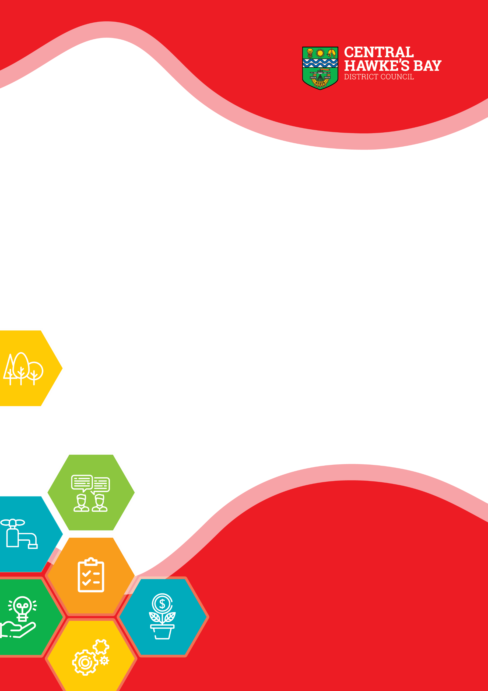
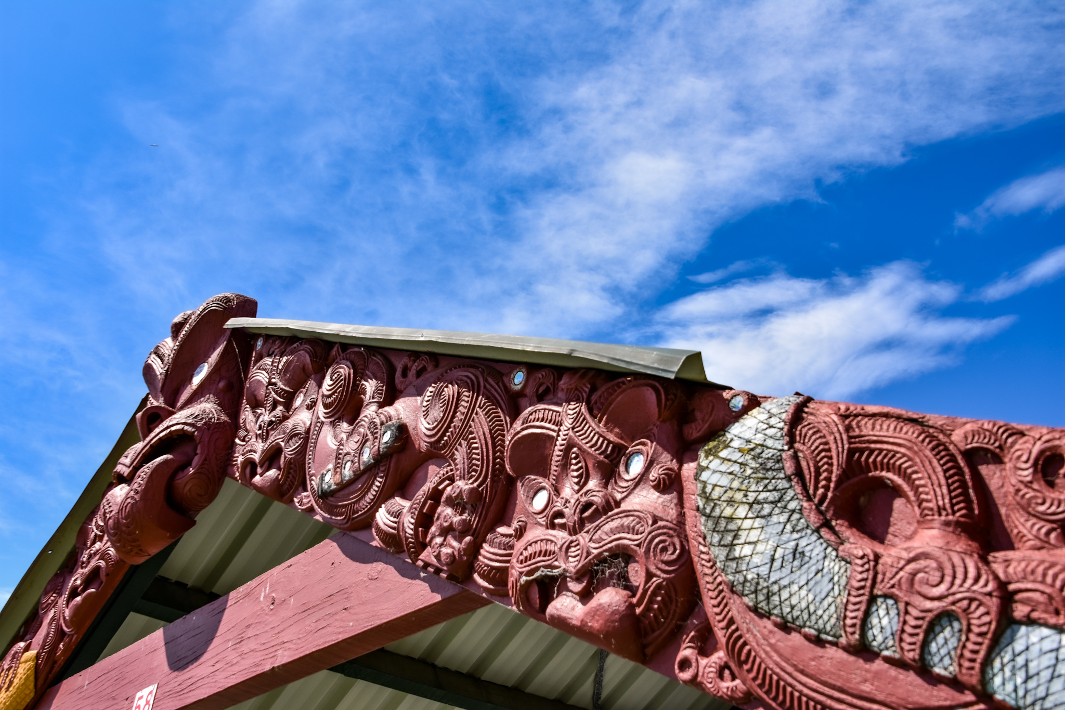
Maori Contribution to Decision Making Policy
Adopted: 00/00/0000 Review Date: 00/00/000

Māori Contribution to Decision Making Policy
As a Council, we recognise the special and unique position of tangata whenua of Tamatea / Central Hawke’s Bay District and the important role Maori have to play in Council’s decision making processes.
We recognise Te Tiriti o Waitangi / the Treaty of Waitangi as New Zealand’s founding document.
Our relationship with and responsibilities to Māori are grounded by this and guided by relevant law.
To enable Māori to work with us, we are committed to fostering the development of Māori capacity to contribute to our decision-making.

Purpose
The purpose of the Maori Contribution to Decision Making Policy is to outline Council’s commitment to enhancing Maori contribution and representation to the decisions that Central Hawke’s Bay District Council makes.

Maori Wards
The Local Electoral Act 2001 gives Council the ability to establish separate wards for Maori electors. Council is required to review its representation arrangements at least once every six years. This review must include deciding whether or not to have separate wards for electors on the Maori roll.
The formula to establish the number of Maori seats is governed by population. Based on the population of this district, it may be possible that one Maori seat could be established.
Council conducted a representation review in 2011 and then again in 2018. At both times Council resolved that “Council does not establish Maori ward/s as provided for in the Local Electoral Act 2001, at this time.”

Maori Representation
Council has historically had a Maori Consultative Committee, and in recent times a Te Taiwhenua o Tamatea representative has attended scheduled ordinary, special, and extraordinary meetings of full Council.
Council, while still committed to enhancing relationships with hapu and marae, recognise the role of Te Taiwhenua o Tamatea as a key vehicle to continue to support and advise Council.
This commitment continues to be acknowledged through the appointment of a Kaiārahi Matua.
The Kaiārahi Matua provides advice and guidance to Central Hawke’s Bay District Council on all forms of Council business that require tangata whenua engagement.
The Kaiārahi Matua is appointed by resolution of Council, following advice and engagement from Tamatea tangata whenua leadership.
Specifically, the role of Kaiārahi Matua is to:
- advocate on behalf of tangata whenua
- consider governance issues relating to obligations to tangata whenua
- report to and give advice to Council on issues or opportunities for tangata whenua
- support the Mayor, Council and Chief Executive on matters related to tangata whenua engagement and development
- provide cultural advice and support as appropriate for events, engagements and other relevant matters.
The Kaiārahi Matua is remunerated at the same level as a base salary “Councillor” and is entitled to claim expenses and mileage as per the Elected Member Remuneration and Expenses Policy.
In addition to the role of Kaiārahi Matua, Council is committed to meeting with Te Taiwhenua o Tamatea board and other Tamatea tangata whenua leadership, to not only enhance the partnership and contribution to decision making but to increase visibility on common objectives and priorities.
Council is open at any time to the development of a formal partnership accord with Te Taiwhenua o Tamatea.

Maori Engagement
Central Hawke’s Bay District Council is committed to enhancing the partnership it has with iwi, hapu and marae in Central Hawke’s Bay.
The Council acknowledges its responsibility under the Local Government Act 2002 and during the development of a Maori Engagement Strategy will be considering further initiatives to:
- identify matters and areas of interest to tangata whenua
- foster consultation with tangata whenua at all levels.
- foster capacity building of Māori to take part in decision making processes
- provide information to assist Māori participation in decision making
- consider options for capacity building of tangata whenua to better enable their participation in decision making processes
- develop bespoke relationships with iwi, hapu and marae across Tamatea / Central Hawke’s Bay
- recognise the special status of mana whenua and take into account the Treaty of Waitangi in resource management decision making processes.
- increase cultural capacity and capability of Central Hawke’s Bay District Council to effectively engage with Tangata Whenua including increasing the level of cultural competency within the Council.

