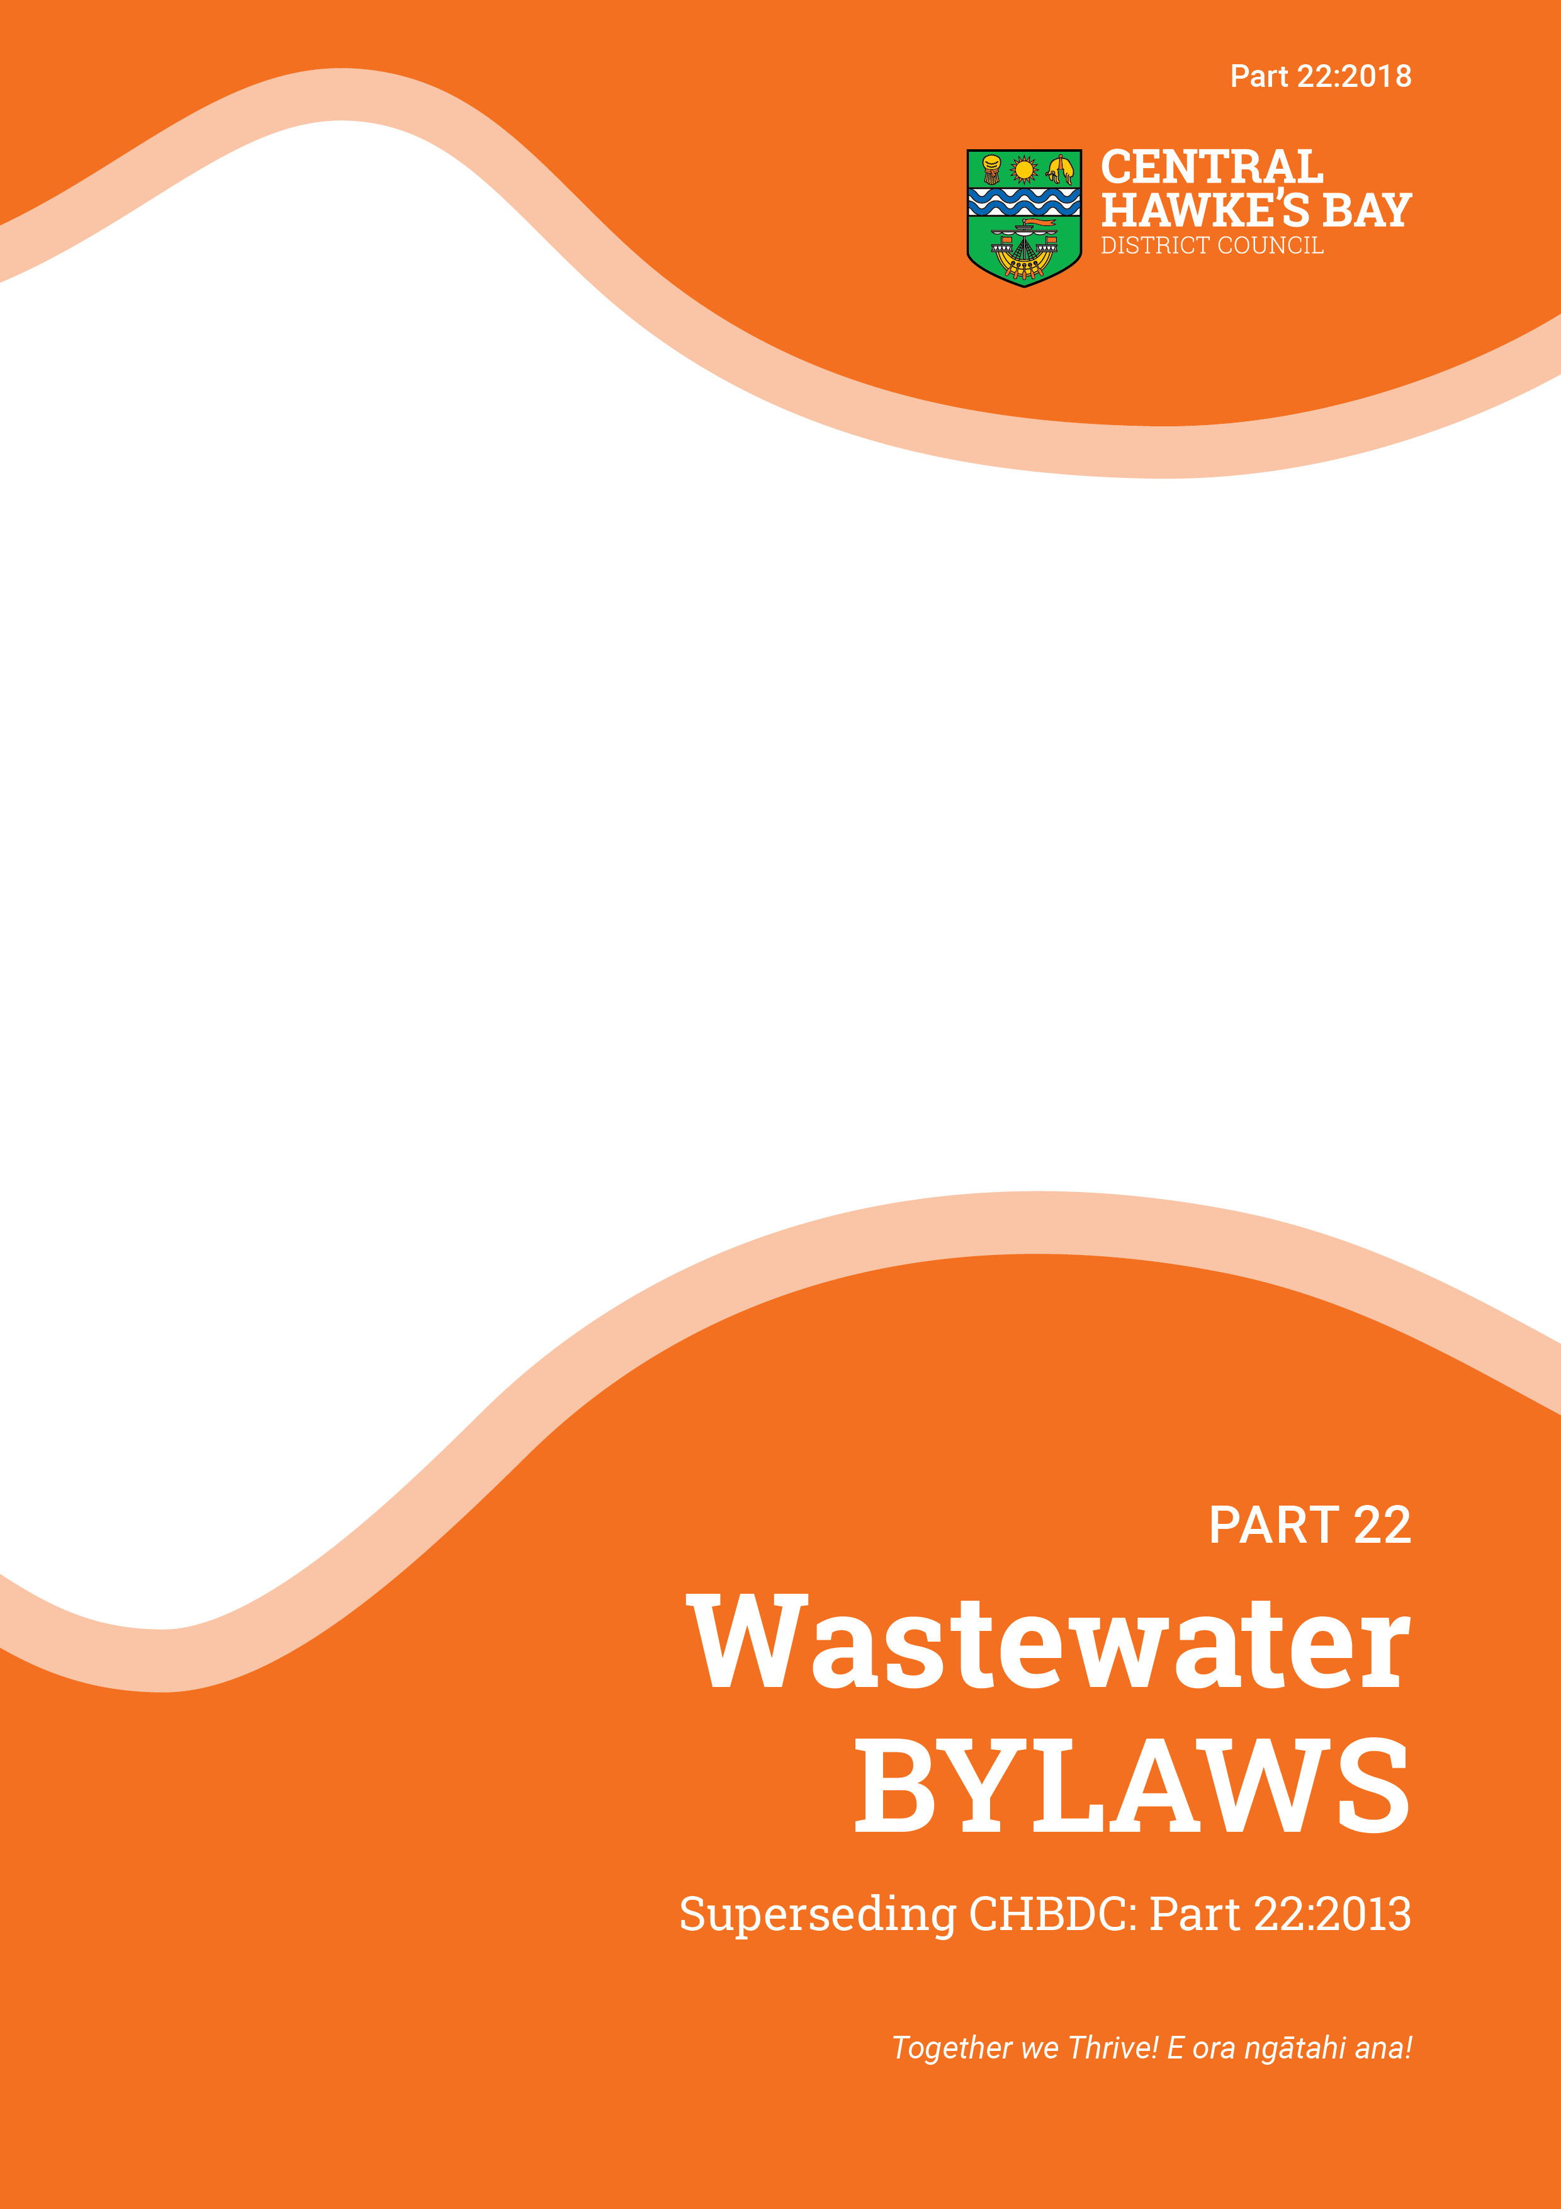

**DRAFT February 2021**

Contents

1. Title 4

2. Commencement 4

3. Repeal 4

4. Definitions 4

5. Access to the Wastewater System 5

6. Working around buried services 5

6.1 General 5

6.2 Excavation, Loading or material over sewers 6

7. Building over buried services 6

7.1 Public Sewers, Rising Mains and Trunk Sewers 6

Customer 8

8. Development of Premises 8

8.1 General 8

8.2 Application for Connection 8

8.3 Pump stations 9

9. Conditions of supply 9

9.1 Wastewater from Holding Tanks 9

9.2 Point of Discharge 9

9.3 Common private drains 13

9.4 Domestic Wastewater 13

9.5 Maximum flow rate 14

9.6 Swimming pools 14

9.7 Prevention of Inflow and Infiltration 14

9.8 Blockages 14

9.9 Disconnection 14

9.10 Emergency 14

9.11 Defect Notices 14

9.12 Remedial Works and cost recovery 14

10. Fees and Charges 15

11. Offences 15

12. Bylaw Approval Date 15

Introduction

To achieve a holistic and integrated approach to three waters management in the District that is consistent with Council’s District Plan, other Policies, Plans, Strategies and Objectives and also reflect the principles of the Te Mana o Te Wai. The following overarching purposes have been set for all four water services bylaws (Water Supply, Stormwater, Wastewater and Trade Waste).

Overarching Purpose

|  |
| --- |
| 1. **Meet Legislation Requirements** Proactively meet all Council’s statutory requirements relating to the provision of three waters services. |
| 1. **Integrated Approach** Adopt an integrated and holistic approach to the Three Waters (water supply, wastewater including trade waste and stormwater) that recognises the interconnections between each of the waters and promotes their sustainable use and management. |
| 1. **Environmental Responsibilities** Facilitate environmentally responsible practices by raising awareness of how the Three Waters interact and effect the District’s natural environment. Additionally, ensure that Council meet its own responsibilities in terms of resource consent requirements set by the Hawke’s Bay Regional Council. |
| 1. **Sustainable Practices** Encourage and incentivise the community and businesses to adopt practices that lead to the enhancement of the environment and the sustainable management of water resources including water and product stewardship, rainwater harvesting, waste minimisation and cleaner production. |
| 1. **Support Sustainable Growth** Support the sustainable provision of three waters infrastructure to enable future growth while minimising impacts on the environment. |
| 1. **Achieve Project Thrive Values** Develop and implement Three Water Bylaws to give effect to ‘Project Thrive’ values in particular trust, honesty, respect, innovation, and valuing people. |
| 1. **Te Mana o te Wai**  Recognise the fundamental concept of Te Mana o te Wai as prescribed under the National Policy Statement for Freshwater Management 2020 and in particular the need to restore and preserve the balance between the water, the wider environment, and the community. |
| 1. **Tangata Whenua Status** Recognise the status of tangata whenua as Kaitiaki. |
| 1. **Durable Infrastructure** Develops and maintain durable and resilient infrastructure that achieves Council’s levels of service in an efficient and cost-effective manner. |
| 1. **Safety and Health** Ensure the protection, safety and health of Council staff and the community when using or operating the water supply system, and the wastewater and stormwater systems. |
| 1. **Obligations** Define the obligations of residential Occupiers and businesses including trade waste Occupiers and the public at large in relation to the Council’s water supply, wastewater and stormwater systems. |
| 1. **Discharge Controls** Regulate wastewater and stormwater discharges, including trade waste, and hazardous substances, into the wastewater and stormwater systems. |
| 1. **Equitable Costs** Provide a system for the equitable share of Council’s water services costs between trade waste dischargers, other businesses and domestic Customers. |

Objectives

Further to the Overarching Purpose the specific objectives for this part of the Bylaw is to promote and protect the health of communities and the environment, and to protect the Wastewater System from damage and misuse.

Context

In Central Hawke’s Bay, there are currently six public Wastewater collection and treatment systems located at Otane, Waipawa, Waipukurau, Takapau, Porangahau, and Te Paerahi.

Wastewater is collected from public and private premises within these systems into the public sewer system. This wastewater is conveyed to the District's wastewater treatment plants for treatment, and is then discharged to the environment. This Bylaw controls the management, treatment and discharge of this wastewater.

Council has responsibility to provide reliable, safe, effective and efficient collection, management and disposal of wastewater and trade waste to ensure that the capacity of available facilities is optimised and that neither public health nor the environment is compromised.

Renewal of wastewater assets is an ongoing process. Pipelines, manholes, pumping stations and treatment plants are renewed as necessary and as funding allows.

Compliance with Resource Consents is also monitored and includes reporting to Hawke’s Bay Regional Council.

Part 22 – Wastewater

# Title

This bylaw shall be known as the Central Hawke’s Bay District Council Wastewater Bylaw [2021].

# Commencement

This Bylaw shall come into force on the **[Date]**

# Repeal

This bylaw supersedes and repeals the Central Hawke’s Bay District Council Wastewater Bylaw 2018 and all amendments of that bylaw.

# Definitions

Reference should be made to Part 1 *Introductory Bylaw* and to the legislation referred to under Referenced Documents, for any other definitions not included in this Part.

For the purpose of this Bylaw, unless inconsistent with the context, the following definitions apply:

|  |  |
| --- | --- |
| **Acceptable Discharge** | means a Wastewater with physical and chemical characteristics which comply with the permitted discharge characteristics of Council’s Trade Waste Bylaw. |
| **Approval** | means approved in writing either by resolution of the Council or by any authorised officer of Council. |
| **Buried Services** | means all public Sewers, Rising Mains, Trunk Sewers and other underground utilities under the responsibility of Council. |
| **Certificate of Title** | means a certificate registering the freehold ownership of land available to any Owner(s) under the Land Transfer Act 1952. |
| **Council** | means the Central Hawke’s Bay District Council or any officer authorised by Council or legislation to exercise the authority of Council. |
| **Customer** | means a person who either discharges, or has obtained a consent to discharge or direct the manner of discharge of Wastewater from any Premises to Council’s public Sewer. The Customer may be an Owner or an Occupier. |
| **Disconnection** | means the physical cutting and sealing of the Drain from a Premises. |
| **Domestic Wastewater** | means either that Wastewater which is discharged from Premises used solely for residential activities, or wastes of the same character discharged from other Premises, provided that the characteristics of the Wastewater are an Acceptable Discharge. Such activities shall include the draining of domestic swimming and spa pools subject to clause 9.6.. |
| **Holding tank** | means a tank installed on a property to store Wastewater from that property, and intended to be emptied regularly by a tanker. This excludes septic tanks where the septic tank forms part of an on-site Wastewater treatment process that is fully contained within the property, and excludes retention tanks where the retention tank is part of a communal Wastewater treatment process. |
| **Infiltration** | means water entering a public Sewer or Private Drain from groundwater through defects such as poor joints, cracks in pipes or manholes. It does not include Inflow. |
| **Inflow** | means water discharged into a drain from non-complying connections or other drain-laying faults. It includes Stormwater entering through illegal downpipe connections or from low gully traps. |
| **Occupier** | the person who occupies the Premises. This may be the Owner of the Premises, lessee, squatter or any other Person on or using the Premises. |
| **Owner** | the Person who owns the Premises. |
| **Person** | includes a corporation sole and also a body of persons whether corporate or incorporate. |
| **Point of Discharge** | means the boundary between the public Sewer and a Private Drain. |
| **Premises** | means either:   1. a property or allotment which is held under a separate Certificate of Title or for which a separate Certificate of Title may be issued and in respect to which a building consent has been or may be issued; or 2. a building that has been defined as an individual unit by a cross-lease, unit title or company lease and for which a Certificate of Title is available; or 3. land held in public ownership (e.g. reserve) for a particular purpose. |
| **Private Drain** | means that section of private drain between the Customer’s Premises and the Point of Discharge through which Wastewater is conveyed from the Premises. This section of drain is owned and maintained by the Customer (or group of Customers). |
| **Rising Main** | means a Sewer through which Wastewater is pumped. |
| **Sewer** | means the main public sewer pipes, manholes and lateral connections that carry away Wastewater from the Point of Discharge. The public sewer is owned and maintained by Council. |
| **Stormwater** | means surface water run-off resulting from rainfall. |
| **Tankered waste** | means water or other liquid, including waste matter in solution or suspension, which is conveyed by vehicle for disposal, excluding domestic sewage discharged directly from house buses, caravans, buses and similar vehicles. |
| **Trade Premises** | means:   1. any Premises used or intended to be used for any industrial or trade purpose; or 2. any Premises used or intended to be used for the storage, transfer, treatment, or disposal of waste materials or for other waste management purposes, or used for composting organic materials; 3. any other Premises from which a contaminant is discharged in connection with any industrial or trade process 4. any other Premises discharging other than domestic sewage; and includes any land or Premises wholly or mainly used for agricultural or horticultural purposes. |
| **Trade Waste** | means any liquid that is or may be discharged from a Trade Premises or tanker to the Council’s Wastewater System of a non-domestic nature. |
| **Trunk Sewer** | means a Sewer, generally greater than 150 mm in diameter, which forms a part of the principal drainage system of Council’s Wastewater System. |
| **Wastewater** | means water or other liquid, including tankered waste and waste matter in solution or suspension, discharged from a Premise to a Sewer (also called sewage). |
| **Wastewater System** | means the collection, treatment and disposal of Wastewater and Trade Wastes, including all Sewers, pumping stations, storage tanks, sewage treatment plants, outfalls, and other related structures operated by Council and used for the reception, treatment and disposal of Wastewater and Trade Wastes. |

# Access to the Wastewater System

### No Person other than Council and its authorised agents may have access to any part of the Wastewater System without the written Approval of Council.

# Working around buried services

## General

### Any Person proposing to carry out excavation work must view the as-built information held by Council to establish whether Council services are located in the vicinity. Excavation work of the following type will be considered as in the vicinity of Buried Services:



### At least five (5) working days notice in writing must be given to Council of an intention to excavate in the vicinity of its services.

### Any Person causing damage or disruption to the Wastewater System is liable for the cost of repairs and any other costs incurred as a result of the damage or disruption.

### No Person may make any connection to, or otherwise interfere with, any part of the Wastewater System except with the written Approval of Council.

### Any damage or disruption to the Wastewater System must be reported to the Council immediately.

### No Person may undertake any excavation work within 2 metres of any part of the Wastewater System, except with the prior written Approval of the Council.

### When granting Approval for excavation work near the Wastewater System, the Council may impose such conditions as it considers necessary.

## Excavation, Loading or material over sewers

### No Person may cause the crushing load imposed on a public Sewer to exceed that which would arise from the soil overburden plus a HN-HO-72 wheel or axle load (as defined by the New Zealand Transport Agency (Waka Kotahi) Bridge Manual).

### No Person may cover or obscure a Sewer without the prior Approval of the Council.

### Removal of any covering material or adjustment of the structures will be at the property Owner’s expense.

### No Person may excavate, or carry out piling or similar work closer than:

#### five (5) metres from the centre line of any Rising Main or Trunk Sewer; or

#### two (2) metres from the centre line of any public Sewer;

without written Approval from Council. Such Approval may impose conditions on the carrying out of any work near the Sewer.

# Building over buried services

## Public Sewers, Rising Mains and Trunk Sewers

### Except in accordance with 7.1.3, no building may be built over a public Sewer, Rising Main or Trunk Sewer, or closer than the greater of:

#### 1.5 metres from the centre of any main or Sewer (Refer to Figure 7-1); or

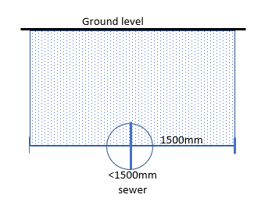

Figure 7‑1: No build zone in vicinity of a public rising main or trunk sewer (less than 1500 mm diameter)

#### the depth of the centre line of the Sewer, plus the diameter of the Sewer, plus 0.2 metres from the centre of that Sewer, subject to compliance with 3.1 of NZS 3604 (Refer to Figure 7-2).

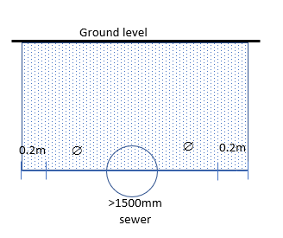

Figure 7‑2: No build zone in vicinity of a public rising main or trunk sewer (more than 1500 mm diameter)

### Subject to Approval, a building developer may meet the cost of diverting the public Sewer (including any manholes) in accordance with Council’s standards.

### Where clause 7.1.1 and 7.1.2 above are found to be impractical and the building cannot be sited elsewhere on the property or modified to conform with the above conditions, and it is essential for the proposed building to be built on that part of the property, approval may be granted subject to the building developer meeting the cost of any specific requirements. These requirements may include:

#### the provision of access manholes, pipe strengthening, ducting, additional support of the building’s foundations and re-locatable construction;

#### carrying out sufficient investigations to accurately determine the Sewer’s location and depth, and to prove that the Sewer is in a condition where it has a remaining life of at least fifty (50) years; and

#### or carrying out remedial work or relaying the Sewer to meet the requirements of:

##### bore piling the building 1.0 metre clear distance either side of the Sewer to below the Sewer invert to ensure that no building loads are transferred to the Sewer and so that it is possible to excavate down to the Sewer without threat to the building;

##### providing two additional manholes into the Sewer between 2.0 and 3.0 metres from the edge of the building at the points it enters and leaves the building (unless there is an existing manhole within 10 metres), provided that the Sewer lies in a straight line and that there are no other connections between these two manholes;

##### carrying out all work on and around the Sewer in accordance with Council’s engineering standards.

# CustomerDevelopment of Premises

## General

### No Person may divert any part of the public Wastewater system except with the prior written Approval of the Council.

### No Person may make a connection to, or otherwise interfere with the public Wastewater System without prior written Approval of the Council.

### All proposed Wastewater works must be designed, constructed and operated:

#### in compliance with any relevant Wastewater Management Plan or discharge consent, including its recommendations or conditions for the area concerned; and

#### to Council’s standards for corresponding public Wastewater works where they serve or may serve land or buildings in different ownership; and

#### to Council’s Wastewater Drainage Policies; and

#### in compliance with any written conditions imposed by Council when approving the works, and with any relevant building or resource consent; and

#### to be consistent with foreseeable catchment-wide works (for example, extending a pipe upstream or downstream) so as to give a benefit to the catchment as a whole.

Such Wastewater drainage works will remain the responsibility of the Owner of the land on which the works occur unless and until they are taken over and vested in Council. The cost of all work involved will be the Owner’s cost unless specific agreement for alternative cost sharing is approved in writing by Council.

## Application for Connection

***Applications must be made to Council to connect to the Wastewater System.***

### Every application for a connection to the Wastewater System must be made in writing on the standard Council form (on Council’s website). The applicant must provide all the details required by Council.

### On receipt of an application Council will, after consideration of the application and other matters relating to the application and the Wastewater System, either:

#### approve the application and inform the applicant of the size of the connection and any particular conditions applicable; or

#### refuse the application and notify the applicant of the decision giving the reasons for refusal.

### Failure to comply with any of the terms and conditions of an Approval constitutes interference with the Wastewater System and is a breach of this Bylaw.

### Any such connection shall be carried out by a registered drainlayer under the supervision of Council.

### Any new connection will be dimensioned from the immediate downstream manhole to the centre of the newly installed connection, and an as-built plan showing the connection shall be provided to Council within seven (7) days of installation and acceptance by Council.

### The applicant must have the authority to act on behalf of the Owner of the Premises for which the connection is sought, and shall produce written evidence of this if required.

### An approved application which has not been actioned within six (6) months of the date of application will lapse unless a time extension has been approved. Any refund of fees and charges shall be at the discretion of Council.

### Every application to carry out Wastewater works must include drawings and specifications for the proposed works. The drawings must show, to the satisfaction of Council, the proposed works and their effects on the subject site and surrounding land.

## Pump stations

### Customers may not use private Wastewater pump stations unless approved in writing by the Council. Approval may only be provided where there are no practical alternatives for a gravity flow discharge to the public Sewer.

# Conditions of supply

## Wastewater from Holding Tanks

### Wastewater from Holding Tanks will not be accepted at any of Council’s Wastewater treatment facilities, unless approved in writing by Council.

## Point of Discharge

### The Point of Discharge marks the boundary of responsibility between the Customer and Council, for maintenance of the Wastewater system, irrespective of property boundaries.

### Unless otherwise approved there may only be one Point of Discharge for each Premises, and any private drain shall not extend by pipe or any other means to serve another Premises unless it is a common Private Drain.

**Single ownership**

### For single dwelling units the Point of Discharge will be located at the boundary as shown in Figures 10.1, 10.2, 10.3, 10.4 and 10.5 or as close as possible where fences, walls or other permanent structures make it difficult to locate it at the required position. The Approval of other positions must be made by Council and recorded on the drainage plan.

### Where aPrivate Drain discharges into a public Sewer on that same private property, the Point of Discharge is the upstream end of the pipe fitting which forms the junction with the public Sewer.

Private Drain

Point of Discharge

Public Sewer

Property Boundary

Public road

Figure 9‑1: Point of Discharge Location - With Street Frontage

Right of Way

Private Drains

Point of Discharge

Public Sewer

Public road

Figure 9‑2: Point of Discharge Location - Rear Lots

Private Drain

Point of Discharge

Private Drain

Point of Discharge

Public Sewer

Private Drain

Private Drain

Point of Discharge

Point of Discharge

Figure 9‑3: Point of Discharge Location - Public Sewer on Private Property

Point of Discharge

Private Drain

Public Sewer

Common Private Drain

Point of Discharge

Figure 9‑4: Point of Discharge Location - Common Private Drain

Private Drain

Private Drain

Point of Discharge

Public  
Sewer

Private Drain

Private Drain

Point of Discharge

Point of Discharge

Figure 9‑5: Point of Discharge Location - Private Drain through Neighbouring Properties

**Multiple Ownership**

### The Point of Discharge for the different forms of multiple ownership of Premises and / or land shall be as follows:

#### for company share / block scheme (body corporate) - as for single ownership;

#### for leasehold / tenancy in common scheme (cross lease), strata title, and unit title (body corporate);- where practicable each Owner shall have an individual drain with the Point of Discharge determined by agreement with Council. If not practicable there shall be a common private drain which shall be incorporated as an additional provision in the lease agreement. In specific cases other arrangements will be acceptable subject to individual Approval.

**Layout**

### The physical drainage layout at a Point of Discharge must be as per the New Zealand Building Code, the New Zealand Standard NZS4404:2010 Land Development and Subdivision Infrastructure, and approved in writing by Council.

## Common private drains

### Common Private Drains may serve a maximum of five (5) single dwelling units, and must have one Point of Discharge only (in common).

## Domestic Wastewater

### No Domestic Wastewater may:

#### exceed the limits for permitted discharge characteristics in Schedule A of the Council’s Trade Waste Bylaw; or

#### contain any of the characteristics prohibited in Schedule B in Council’s Trade Waste Bylaw.

### Where part of a domestic Premises is used as an office or other trade related activity from which no Trade Waste could be produced, and which no other Persons apart from those living at those Premises use, then it may be treated as domestic Premises for the purpose of this bylaw. Any trade activity which produces or has the potential to produce a Wastewater will be treated as being from Trade Premises.

## Maximum flow rate

### The maximum instantaneous flow rate discharged from a domestic Premises must not exceed 2.0 litres/second and / or 5m3 per day.

## Swimming pools

### Swimming and spa pool drains must be fitted with a flow limiting device to ensure any discharge does not exceed a maximum instantaneous flow of 2.0 litres/second.



## Prevention of Inflow and Infiltration

### The Customer must take all reasonable steps to prevent any Stormwater or groundwater entering the Wastewater System (including from roof downpipes, surface water run-off, overland flow, and sub-surface drainage). Reasonable steps include ensuring that:

#### there is no direct connection of any Stormwater pipe or drain to the Wastewater System;

#### gully trap surrounds are sealed and set above Stormwater ponding levels (refer New Zealand Building Code G13), or secondary overland flow path flood levels;

#### inspection covers are in place and are appropriately sealed;

#### Private Drains are kept and maintained in a state which is free from cracks and other defects which may allow Infiltration.

## Blockages

### Any Person who causes a blockage in a public Sewer, by discharging non-acceptable wastewater, or by forcing a blockage downstream into the public Sewer in the course of clearing a Private Drain is liable for the cost of unblocking the public Sewer.

## Disconnection

### A Customer must give seven (7) working days notice in writing of their intention to demolish or remove a building connected to the Sewer. The demolition or removal must not commence until the property has been disconnected from the Sewer by Council.

### A Customer must give two (2) working days notice in writing to Council of their requirement for Disconnection of the discharge connections if relaying of the private Drain is required.

## Emergency

### During an emergency, Council may restrict or prohibit the discharge of Wastewater for any specified purpose, for any specified period, and for any or all of its Customers.

### Any such restrictions shall be publicly notified.

## Defect Notices

### In the event of a breach of this bylaw, Council may serve a defect notice on the Customer advising its nature and the steps to be taken within a specified period, to remedy it. If, after the specified period, the Customer has not remedied the breach, Council may charge a re-inspection fee.

## Remedial Works and cost recovery

### The Council may:

#### Remove or alter any work or thing that is, or has been, constructed in breach of this bylaw; and

#### Recover the costs of removal or alteration from the Person who committed the breach.

# Fees and Charges

### Council may prescribe fees and charges relating to matters provided for in this bylaw in accordance with section 150 of the Local Government Act 2002.

# Offences

### Every Person who breaches this Bylaw, or fails to comply with a notice served under this bylaw commits an offence and is liable upon conviction to a fine as provided for under the Local Government Act 2002, and may be liable to penalties under other legislation.

# Bylaw Approval Date

The Common Seal of the Central Hawke's Bay District Council was attached, under Resolution *(Reference - Part 22: Wastewater Bylaw 2018)* passed at a meeting of the Central Hawke's Bay District Council held on …….................... (Day) ……….….....….... (Month) ….…............ (Year).