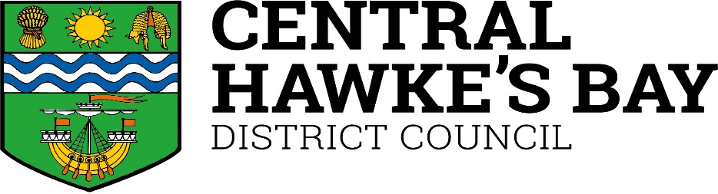
Ruataniwha Street
PO Box 127
Waipawa 4210
New Zealand

Phone: 06 857 8060
Fax: 06 857 7179

Email: customerservice@chbdc.govt.nz
www.chbdc.govt.nz
info@chbdc.govt.nz
www.chbdc.govt.nz

Request for Rural RAPID Number

Property Owner’s Details
Name

Postal Address

Contact Phone Email

Property Details
Valuation (if known)

Legal description of property where entrance is located (if known)

Name of road where entrance is located

Location of Property
In order to accurately identify your property, please provide the following information (if known):
Approximate distance from beginning of road to entrance OR Fill in the RAPID numbers on either side of the property on your side of the road
kms OR between and

Any other information that will help to locate the entrance, ie, nearest intersection, features at your entrance (eg, wrought iron gates, feature wall, distinctive hedging) or nearest culvert marker peg, etc.

If dwelling is down a driveway with multiple properties and this has already been numbered, please include the number at the entrance

Is the property part of a recent subdivision? ☐ Yes ☐ No

Central Hawkes Bay District Council
Rural RAPID Number Application Page 1

Type of Request (please tick)

New RAPID Number Plate*
- Measure and install new RAPID number plate ☐ Measure new RAPID number, no plate supplied

☐ Measure RAPID number and post new number plates

Replacement RAPID Number Plate*
- Install replacement RAPID number
plate ☐

Supply replacement RAPID number plate by mail

Signature Date

For Council Use

Land Transport Team Customer Services

RFS No Fee Payable

RAPID No GL Code

Date Installed Date Paid

Date Owner Advised Receipt No

Central Hawkes Bay District Council
Rural RAPID Number Application Page 2

Rural Address Property Identification System (RAPID)

What is a RAPID Number and how are they allocated?
RAPID numbers can be used for any rural entrance that requires an address (eg, dwellings, sheds, yards, etc, spread over the property). RAPID numbers will help ensure that emergency services, visitors, utility operators and contractors can easily locate your property.
The RAPID System is a standard numbering system for rural properties based on the distance to a property entrance from a clearly defined reference point, usually the beginning of the road on which it is located. The numbers are allocated to properties by measuring the distance from the beginning of the road to the centre of the entrance to the property. This measurement is taken in metres, divided by 10 and rounded to a whole number.
Numbers on the right side of the road are allocated as even numbers, while those on the left side are odd. For example a property with a driveway that is 375 metres from the beginning of the road would be allocated the RAPID number 38 on the right side of the road and 37 if it was on the left.
If there are is more than one dwelling on a driveway, then a letter (eg, A, B or C) is added. The first house along the driveway will be A, the second B, etc.
If you have a shared driveway, you can request an additional plate to put on the house.

How are RAPID Numbers used?
As RAPID numbers are allocated, the information is sent to Land Information New Zealand’s national property database. Emergency services have access to this information so they can quickly and accurately locate rural properties.

How do I find out if a property has a RAPID Number?
A white number plate with red numbers will be attached at the entrance to the property. If no number is visible but you think a number may have been allocated please contact Council and we will check the property database. If a number has not been allocated you may apply for one.

How do I apply for a RAPID Number?
In order to supply a RAPID number Council needs accurate information to identify the property and its location. Please complete the RAPID number application form, available from Council offices and on our website.

How long will it take to receive a RAPID Number?
Numbers will be allocated as soon as possible, if the application has been completed correctly and all relevant information has been supplied to Council. A plate with the allocated number will be made up. You can have the option of having the plate posted to you to install yourself, or have Council install it for you. Note that there are different fees for each option.

Where are RAPID plates installed?
Your RAPID plate should be attached in a prominent position close to your vehicle entrance, which could be on a letterbox, gatepost or wooden fence. Plates are to be fixed parallel to the road. They have reflective red numbers for ease of visibility, especially at night.

What if I have a problem with my RAPID Number?
It is not possible to change a number on request as it is based on the distance along the road. If you change the location of your entranceway please contact Council.

How do I apply for a replacement RAPID Number plate?
If you have an existing RAPID number and need a replacement plate, please complete the application form.

What happens if Isubdivide?
If you are subdividing, new RAPID numbers will be required for any new entrances created. The existing entrance will retain the current RAPID number and this number with a suffix (eg, A, B, C, etc) will be allocated to any new lots using the entrance. This is because the RAPID number is based on a measured distance along a road. However if there are five or more lots being created and they all gain access from this right of way then a new road name will be required. Please contact Council for further information on this requirement.

What happens if I build a new house or form a new entranceway?
Any new entranceway created to a new building on a property will require a new RAPID number.

Can I have a RAPID Number if I have no road access?
RAPID numbers are only allocated to properties with entranceways off a road.

How will having a RAPID affect my address?
The RAPID number should be added to the usual Rural Delivery address (eg, Joe Bloggs, 883 Nowhere Road, State Highway 4, RD1, Taumarunui 3994).

What happens to RAPID Numbers in towns?
Where a town has no existing numbers, the RAPID numbers are continuous through the township.
If urban numbers exist, the RAPID stops at the commencement of same and starts again where urban numbers end, but the distance measurements continue through the town and starts again on the other side.

Central Hawkes Bay District Council
Rural RAPID Number Application Page 3

